ASSIGNMENT - 1

Create sample table and inserting values.
Create the following tables with the given structures and insert sample data as specified :-

A) SALESPEOPLE
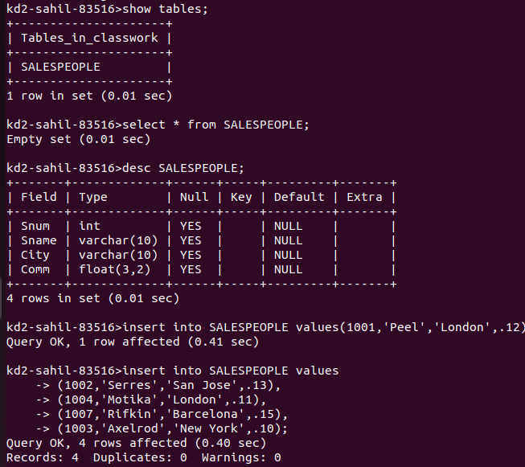
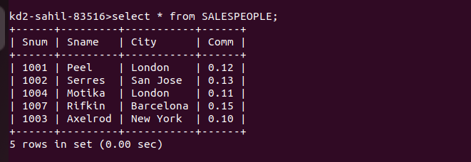

B) CUSTOMERS
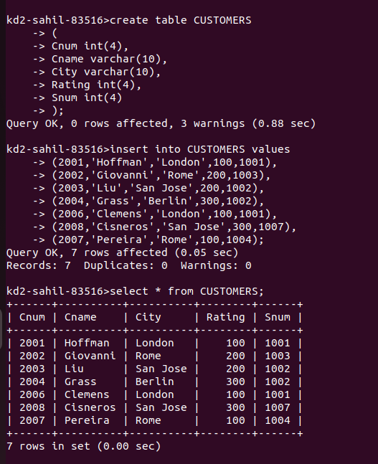

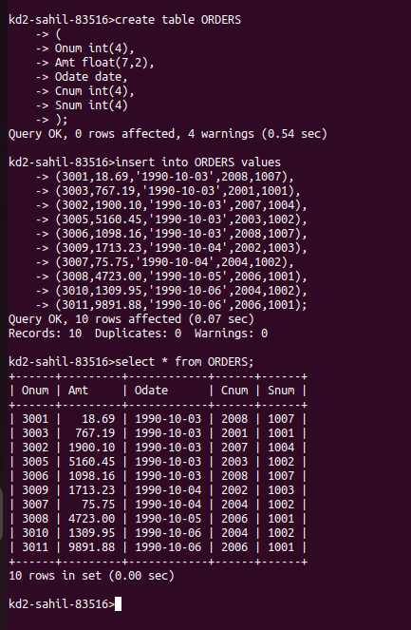
C ) ORDERS

